**UTAMCB201904DATA3/01-Excel/Homework**

**Ezra Kenigsberg**

**2019-05-16**

1. **Given the provided data, what are three conclusions we can draw about Kickstarter campaigns?**

I focused on **which Kickstarters succeed, and why**.

Looking at the data from 2009-2016 (excluding 2017’s Kickstarters, a third of which were live),

1. there’s an argument to be made for **Kickstarter Fatigue**. Once Kickstarters spiked in 2014, the success rate of Kickstarters dropped more than 20 percentage points.
2. **the Performing Arts had the most successful Kickstarters**. Music, Theater, and Film & Video had the highest success rates. Zero (?!) journalism Kickstarters succeeded.
3. **size matters** (but maybe not the way you think)**.** Unsuccessful Kickstarters had a higher Goal than the Kickstarters that succeeded.

* Year-by-year, **successful Kickstarters’ Goals grew dramatically less than unsuccessful Kickstarters’ Goals**.
* The Kickstarter Goals exceeding $500K were all created after 2013. Of those, 42% had no backers, compared to a 10% no-backer rate for the entire dataset.

1. I’m sad they cancelled both Kickstarters for TV shows about **zombies in Ancient Rome**. I totally would’ve watched those.
2. **What are some limitations of this dataset?**

* **Tricky filtering**.The aggregated data are hurt byKickstarters I judge to be
  + patently bogus (eg, the $100MM movie that collects zero pledges);
  + unusable because they’re live (one-third of the 2017 Kickstarters); or
  + disingenuous in their goal (eg, the wireless sound system with a goal of $1 that raises $22K).

But it’s hard to know what objective standard would winnow them out and give us a set with more “true” data. I’ve gone with “pre-2017 Kickstarters with at least one backer.”

* **Ugh, regression.** The few regressions I ventured had good coefficient P-scores but terrible R-squareds. Yes, Kickstarters with larger Goals and later Date Createds have lower success rates. But the huge majority of the variance remains unexplained.

1. **What are some other possible tables and/or graphs that we could create?**
2. This graph illustrates **Kickstarter Fatigue**:

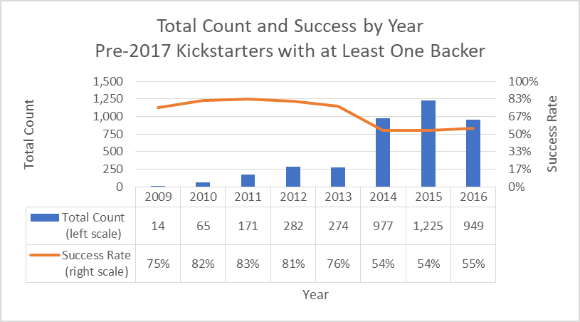

1. This graph shows the **higher success rate of Performing Arts** (Music, Theater, and Film & Video):  
   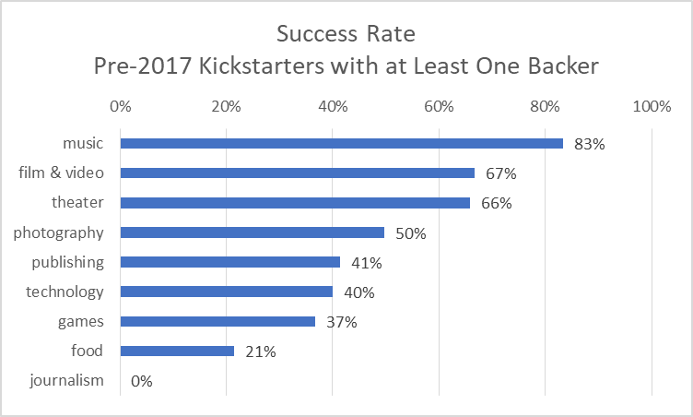
2. This graph shows how successful Kickstarters’ Goals have stayed relatively constant, while unsuccessful Kickstarters’ ambitions have grown:  
   